PERSIA CHART
The Edo Japan
The Japanese as well have their way of life based on the PERSIA chart that clearly elaborates who they are and how they live. It includes their system of governance, their social relationships, their economic and religious activities and beliefs and their geographical adaptations as well. Below is Japan’s PERSIA Chart:
Political: who is in charge?
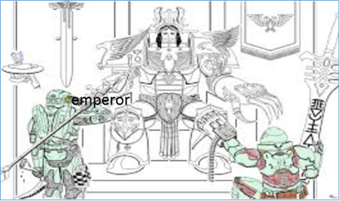

Economic: how do we make a living?

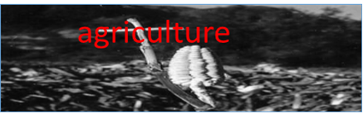
Religious: what do we believe?
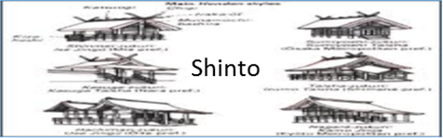

Social: how do we relate to another?
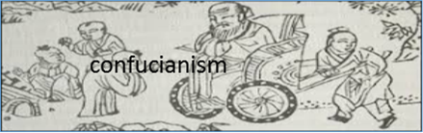

Intellectual/Artistic: how do we learn? How do we express ourselves?

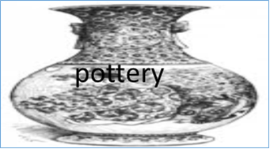
Area/Geographical: how does where we live impact how we live?
